**Reduced Order Thermal Model for the “Varennes Library”**

*Anthony Maturo*

This chapter describes the modelling approach established to create a reduced order model to study the thermal response of the Varennes Library. The developed model gives information on the main thermal dynamic of the building, accounting for radiant and convective heating. The chapter is divided in three main parts or sections.

Section 1 refers to the preliminary data analysis, which deals with the difficulties over the modelling for this type of building. It considers the importance of the mechanical system and the temperature trends over the definition of the model.

Section 2 describes the modelling approach, which introduces the methods used to characterize the thermal dynamic of the building.

Finally, Section 3 describes the calibration and validation of the model and deals with the methodology that provides a reliable model with prediction capabilities of 24 hours ahead.

1. **Preliminary analysis**

The Varennes Library is an institutional building characterized by four geothermal heat pumps, building integrated thermal photovoltaics and building integrated photovoltaics, a dedicated outdoor AHU, floor heating systems, displaced ceiling and floor ventilation, and localized fan coils. The goal of this section is to establish some preliminary insight that facilitates the choice of the type of thermal model and its detail.

Several difficulties affect the definition of a proper model to evaluate the energy load of this type of building. Hence, it is necessary to introduce the following concepts for the model definition:

* *Temperature trend for each thermal zone*: after an extensive study of the main temperature trends inside the library, it was possible to identify two main thermal zones for the first floor and one main thermal zone for the second floor. This result is justified by the presence of large open space areas inside the library. This zoning or aggregation-based methodology is supported by the concept of zone-based models which is commonly adopted by the HVAC community [11].
* *Different boundary conditions affecting the first and second floor*: the effect of solar radiation is higher for the second floor. This statement supports the need to distinguish the two floors in the model.
* *Mechanical system*: its schematic distinguishes dedicated ducts and dampers which controls separately the ventilation at the first and second floors. Also, the location of the floor heating systems and the ventilation terminals changes from first to second floor.
* *Combination of different heating/cooling technologies placed in each thermal zone*: the developed model must allow the study of the fast and slow thermal response of the building due to the different type of terminals.

These axes were considered during the modelling of the building, identifying the following thermal zones and main features of the building (from the floor heating to the ventilation). The aggregation of thermal zones in an open space environment allows a simple and accurate evaluation of the temperatures and energy levels requested by the building. With this hypothesis, the uncertainty due to the thermal zone interaction is limited.

Given the open space zones, considering each zone temperature uniformly distributed vertically and horizontally is a strong hypothesis. Therefore, the different temperature trends, obtained from thermostats located in different position inside the library, showed a small deviation (0.5-1°C). This led to the selection of two thermal zones for the first floor.

At the same time, more concern is given to the second floor. This floor is characterized by a higher height which can cause the problem of vertical gradient. This issue is partially solved inside the building by means of ceiling fans which force the heated air in the occupied area. The combination of these fans with the radiant terminals creates a micro-clime which limits the effect of the vertical gradient in the occupied area. This combination supports the strong hypothesis of considering one temperature value, or single thermal zone, for the second floor.

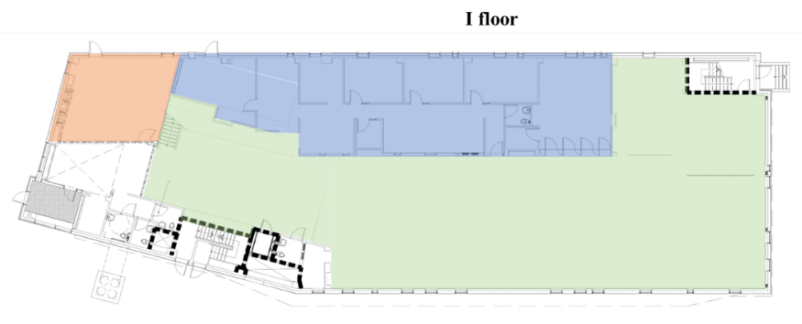

Figure 1: Layout of the main zones in the first and second floor considered in the developed model.

Figure 1 describes the layout of the library and the considered thermal zones: two for the first floor, highlighted in blue and green, and one for the second floor, highlighted in green. This discussion establishes the creation of a grey-box model or RC-network with five different nodes. These nodes are described in detail in Table 1.

Table 1: RC-network nodes described in detail.

|  |  |
| --- | --- |
| **Node** | **Description** |
| 1 | First floor air node of the south-oriented zone. |
| 2 | First floor air node of the north-oriented zone. |
| 3 | Second floor air node. |
| 4 | Radiant slab node of the first floor. |
| 5 | Radiant slab node of the second floor. |

1. **Modelling approach**

The building thermal response is modelled using a resistance capacitance (RC) thermal network approach. RC networks aim to capture the dominant building physics while ignoring the nonlinearities that complicate controller design, and making them suitable for building control applications [13]. The building is divided into different nodes in which a building mass is lumped, using a zero-dimensional approach [3]. Every $i$-th node temperature is described by a differential equation, that accounts for both internal and external solicitations and is governed by Equation (1):

  ()

where  represents the temperature of node $i$ [K],  is the thermal capacity of node $i$ [J/K],  represents the temperature of the node $j$ adjacent to node $i$ [K],  is the thermal resistance between the nodes and [m2K/W],  is the sensible heat gain networked to the indoor air node due to convective sensible internal gains due to occupants, lights and equipment [W],  accounts for infiltration/ventilation thermal load [W],  is the sensible heat supplied to or removed from the building space by the HVAC system to maintain the indoor air at the desired set point temperature [W].

* 1. *Occupancy influence*

The occupancy is an important factor when considering building applications, especially for institutional ones. The effect is mainly related to the set point used in the environment. Therefore, in commercial and institutional buildings the occupancy is highly impacting the internal gains. The developed model allows to take into account of the effects of the occupants directly by considering a convective heating quota inside the previous formulation.

* 1. *Ventilation and floor heating modelling*

The ventilation is taken into account with an energy balance to the ventilation system. The amount of energy provided in the environment is evaluated with the following equation:

 ()

Where  is the flow rate circulating in the fan coil and delivered to the thermal zone,  is the specific capacity of the air [J/kgK],  is the temperature at the outlet of the fan coil,  is the temperature of the thermal zone. For simplicity, this measurement is provided directly in [W], in the input file.

Instead, the floor heating is modelled using a lumped parameter approach [3]. With this method it is possible to calculate the amount of energy stored in the floor and released to the environment. Hence, the thermal zones characterized by the floor heating are equipped with another capacitive node which considers the interaction between the air and the thermal mass.

It should be noted that convective and radiative heat transfer are inherently nonlinear processes and the respective heat transfer coefficients are usually linearized so that the system energy balance equations can be solved by direct linear algebra techniques and possibly represented by a linear thermal network. Therefore, in this study it is considered a constant value of this coefficient.

* 1. *Model archetypes*

The structure of the model refers to a combination of different model archetypes which model the building dynamic by floor and dividing it according to its orientation. Several studies demonstrate that by using this level of resolution it is possible to follow the building dynamic and have information on the building load with good accuracy [1].

The model related to the first and second floor of the library are described in the following figures. Together they form a 5C6R RC network.

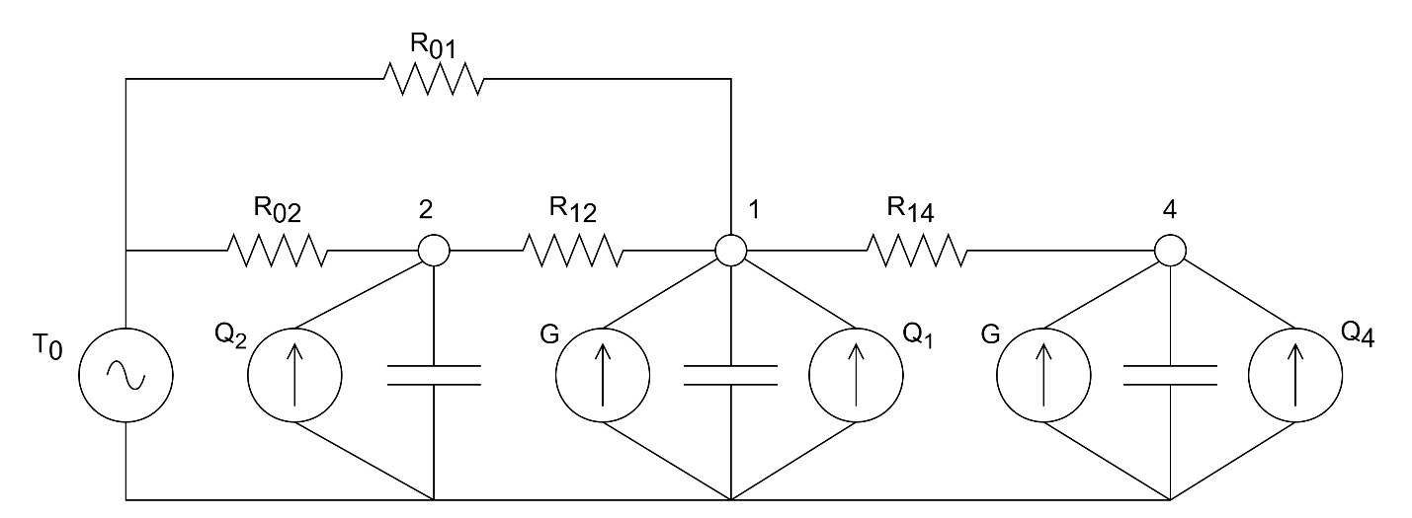

Figure 2: RC networks for the first and second floor.

1. **Calibration and validation**

The model is calibrated with measurement from the thermostats placed the library. The inputs are provided in an associated file which is generated by lumping some thermal zones of the library in single nodes. The lumping approach, for the thermal zone and slab temperatures, is obtained by averaging the measurement by area.

The optimization routine is executed by using a MATLAB function, *fmincon*, a non-linear programming solver that finds the minimum of a specified function. The algorithm is highly influenced by the initial condition; thus, the optimization process is combined with a constrained Latin Hypercube Sampling [14]. However, the selection of the building model and the identification of the parameters is affected by the end use of the model. If the purpose is model predictive control (MPC), the performance of the model over the prediction horizon is of the highest concern. The MPC relevant identification (MRI) method is used to calibrate the model parameters. This method is based on the minimization of the following cost function:

$J\left(k\right)=\sum_{j=1}^{ph}{{\left\|y_{m}\left(k+j\right)-\hat{y}\left(k+j\right)\right\|}_{2}^{2}}$ (3)

Where $y_{m}$ is the measured value, $\hat{y}$ is the estimated value, and $ph$ is the lengths of the prediction horizon. Since multiple models are generated according to the number of initial guess for the parameters, the selection of the one that better follows the thermal dynamic is addressed by means of the FIT function [15]. This index is generated from the knowledge of the Normalized Root Means Square Error (NRMSE).

()

Where is mean value of the measured output. The $FIT$ index is instead evaluated as follows.

$FIT=\left(1-NRMSE\right)∙100\%$ (5)

The calibration routine is executed for a period of one week and for each time step, focusing on a prediction of 24 hrs ahead. The model is finally validated over week to show the performance of the adopted methodology.

1. **Results**

The results of the developed model are shown in this section considering the performance for a prediction horizon of 24 hours ahead. The results are summarized, for each node, in the following tables and figures.

In detail, Table 2 and Figure 3 provide the results during the training period, while Table *3* and Figure 4 refer to the results during the validation period.

More details on the data and the obtained matrices can be found in the MATLAB script[1]. Here, it is possible to test the performance of the model for different prediction horizons and periods.

Table 2: Model performance for prediction of 24 hours ahead during the calibration period (21/12/2017 – 28/12/2017).

|  |  |  |  |  |  |  |
| --- | --- | --- | --- | --- | --- | --- |
| **Node** | 1 | 2 | 3 | 4 | 5 | Total |
| **RMSE** | 0.187 | 0.256 | 0.288 | 0.102 | 0.391 | 0.245 |
| **FIT** | 69.73 | 68.66 | 61.24 | 57.01 | 52.55 | 61.84 |

Table 3: Model performance for prediction of 24 hours ahead during the validation period (28/12/2017 – 01/02/2018).

|  |  |  |  |  |  |  |
| --- | --- | --- | --- | --- | --- | --- |
| **Node** | 1 | 2 | 3 | 4 | 5 | Total |
| **RMSE** | 0.435 | 0.524 | 0.561 | 0.167 | 0.556 | 0.449 |
| **FIT** | 50.48 | 52.36 | 40.90 | 56.20 | 34.05 | 46.80 |

Figure 3: Performance of the model for 24h prediction during the calibration period (21/12/2017 – 28/12/2017).

Figure 4: Performance of the model for 24h prediction during the validation period (28/12/2017 – 01/02/2018).

1. **Limitations**

The study was limited to the definition of the building thermal response during only the winter period. The developed model provides a good prediction accuracy of the whole building thermal load and gives the possibility to distinguish a fast and slow dynamic of the heating, due to the effects of the ventilation and the radiation from the slab.

The values of the RMSE are acceptable for the developed model, therefore, further detail is necessary to increase the accuracy related to the FIT index.

Future studies will address the presence of hidden model states, corresponding to walls and internal mass nodes. Also, future studies will consider the presence of a variable heat transfer coefficient between the radiant slab and the air node. These improvements could highly increase the performance of the developed model.

It is important to highlight that the two floors are modelled separately, hence, no interaction between the floors is considered in this study. This choice is supported by the difficulties in considering a proper evaluation of this term due to the actual activation of the heating terminals inside the building and the negligible difference in temperature between the two thermal zones.

1. Created using the version MATLAB 2023a.